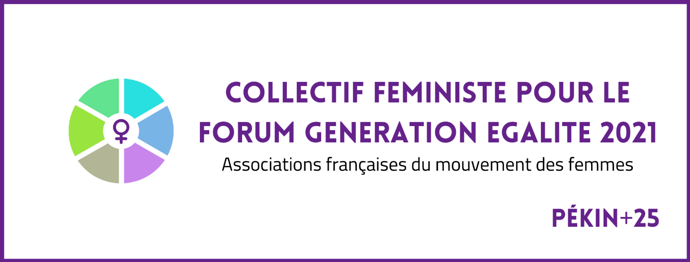

FEMINIST COLLECTIVE
FOR THE GENERATION EQUALITY FORUM
2021
FRENCH ASSOCIATIONS OF THE WOMEN'S MOVEMENT
MANIFESTO
September 3rd, 2020

For the effective implementation of rights and real equality between women and men.

At a time when we are celebrating the 25th anniversary of the World Conference on Women's Rights in Beijing, a crucial anniversary for the future of these rights, we, associations and national platforms of feminist associations, committed to the feminist movement in France, in Europe and in the world, assert our unity, our solidarity and our determination to work together. We recall the common foundation of values that unite us in the history of the women's movement, which are decisive for the foundation of the values of global governance.

At the beginning of the 21st century, de facto equality does not yet exist anywhere. Yet, we are living a decisive moment for women's liberation and revolt; a global movement for women's rights and for equality between women and men is on the march. The scale of inequality and violence against women is evidence of the greatest scandal of human rights violations, for which impunity remains widespread.

These are principles and values that the international community is committed to upholding.

We are united in the objective of achieving real equality between women and men, which is both a universal human right and a fundamental value, proclaimed and imposed in all areas by treaties of European and global scope*. This value permeates the other founding values, such as human dignity, freedom, democracy, the rule of law, pluralism, justice, solidarity, as well as any other fundamental right and any action by the international community. It is at the heart of the values that underpin the democratic and social model that the United Nations and the European Union are primarily intended to promote. It is the sine qua non for universal peace, stability and sustainable development based on solidarity .
These treaties affirm the universal and non-negotiable nature of the fundamental rights of women and girls, which are an inalienable and indivisible part of human rights. They absolutely exclude that ethnic, cultural, religious or linguistic traditions or customs may be invoked to prevent the exercise of these rights. They require States to take all appropriate measures to eliminate prejudices and customary and all other practices which are based on the inferiority or the superiority of either of the sexes or on stereotyped roles for men and women, leading to the violation of women's rights.
These treaties are not limited to prohibiting discrimination on the basis of sex. They require the fight against all inequalities and violence affecting women, half of the world's population, and the promotion of real equality between women and men in all areas, a principle whose concrete implementation requires a comprehensive political strategy and adequate positive measures.

Acting in the face of setbacks in equality between women and men.

Our feminist associations are sounding the alarm on the regression of equality between women and men and on the violent attacks that threaten women's lives and rights. They culminate today in times of health, climate and democratic crises, in a context of deregulation, especially economic deregulation, with devastating effects on the human population and the environment, and the rise of reactionary, anti-democratic forces and religious fundamentalism.

Together, we commit ourselves to act to safeguard, enrich and effectively enforce this international and European acquis in terms of equality between women and men and women's rights; to allow universal access for women and girls to these fundamental rights; to respect the right to abortion, a fundamental right which is currently in decline in many countries and during periods of crisis; to respect the inalienability of the human body and to refuse any instrumentalisation, exploitation or commercialisation of women's bodies. We unconditionally subscribe to the abolitionist principle of the prostitution system adopted by France and to the prohibition of Gestation for others.
Finally, we commit ourselves to the defense and strengthening of the associations of the women's movement, which are today weakened by the infringement of rights and the lack of public financial support.

To this end, we constitute a collective of information, reflection, action and solidarity. We want to make our voice heard in the continuity of our history and that of the struggles of women and feminist associations, whose great diversity of approaches and issues they deal with does not prevent us from recognising ourselves in these values, principles and fundamental rights.

Within the framework of Beijing+25 and the Generation Equality Forum process, we are going to affirm and promote all these values, principles and fundamental rights in a dialogue that we want to be permanent and open with the French government, public authorities at national and European level, international organisations, including the United Nations Organisation, and other civil society organisations.

This declaration is co-signed by the following feminist associations:

First signatories :
Adéquations
Administration moderne
AFEM (Association des femmes de l’Europe Méridionale)
AFFDU (Association des femmes diplomées de l’Université)
Alliance Internationale des Femmes
Amicale du Nid
BPW France
CIAMS (Coalition internationale pour l’abolition de la maternité de substitution)
Collectif et Réseau féministe Ruptures
CQFD Lesbiennes Féministes
Du côté des Femmes
Réseau Fédération Nationale Solidarité Femmes
Femmes au-delà des mers
Femmes du Monde et Réciproquement
FDFA (Femmes pour le dire, femmes pour agir)
Forum Femmes Méditerranée
Femmes Monde
Femmes Solidaires
L’Assemblée des femmes
La CLEF (Coordination française pour le Lobby Européen des Femmes)
Olympe
Osez le féminisme !
Parité
Réussir l’égalité femmes-hommes

*We refer, in particular, to the European Convention on Human Rights (ECHR) and the case law of the European Court of Human Rights; the revised European Social Charter and the case law of the European Committee of Social Rights; the Council of Europe Convention on Preventing and Combating Violence against Women and Domestic Violence (Istanbul Convention); European Union treaties including the EU Charter of Fundamental Rights (Art. 2 and 3 TEU, 8 TFEU, 21, 23 Charter) and the case law of the Court of Justice of the EU (EU Court) the Universal Declaration of Human Rights (UDHR), the founding Charter of the United Nations, as well as international treaties, in particular the International Convention on the Elimination of All Forms of Discrimination against Women (CEDAW); the UNESCO Convention on the Protection and Promotion of the Diversity of Cultural Expressions (UNESCO Convention); the 1995 United Nations Beijing Declaration and Platform for Action (Beijing Platform); the Declaration and Action Plan of the 1993 Vienna Conference (Vienna Declaration); the Council of Europe White Paper on Intercultural Dialogue (CoE White Paper). add Convention on the Rights of Persons with Disabilities CRPD, International Convention on the Rights of the Child (CRC).

